# CS 255 System Design Document Template

**Allen Fox**

## UML Diagrams

### UML Use Case Diagram

### UML Activity Diagrams

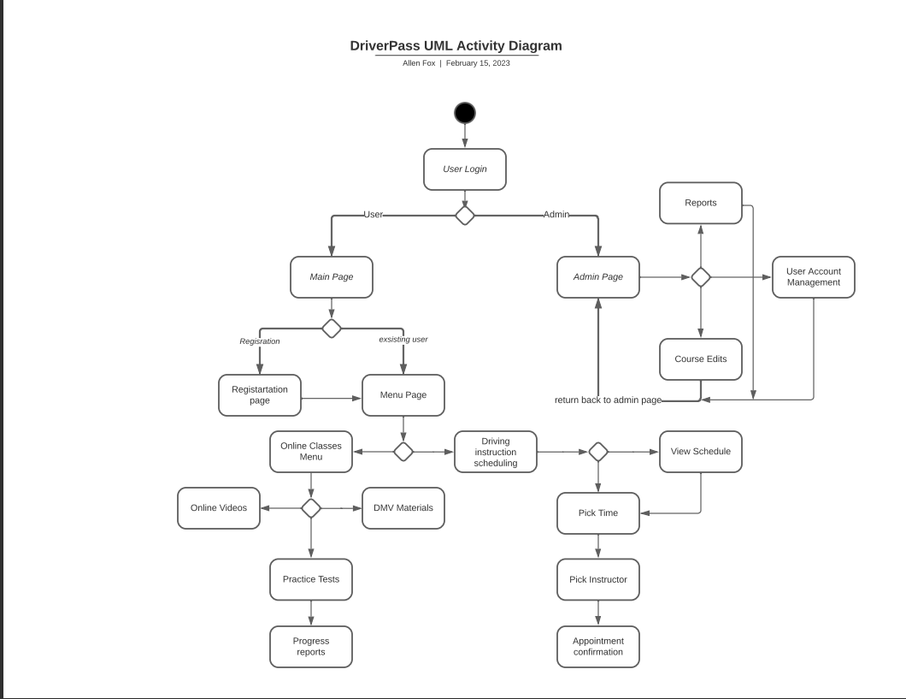

### UML Sequence Diagram

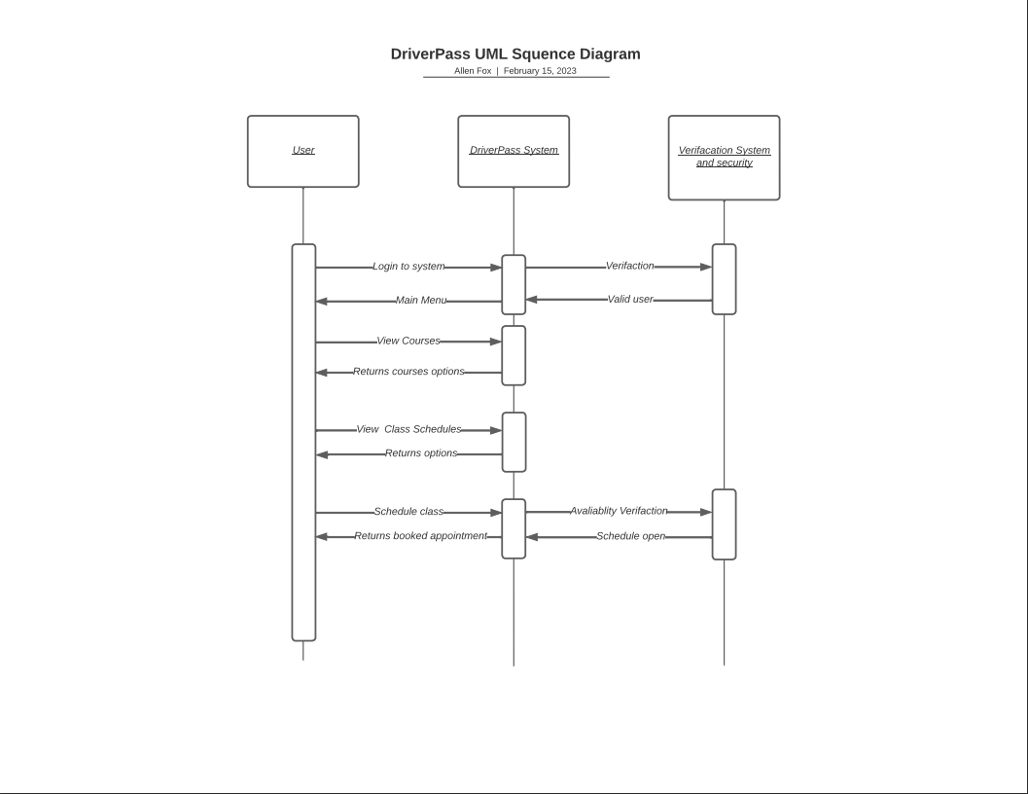

### UML Class Diagram

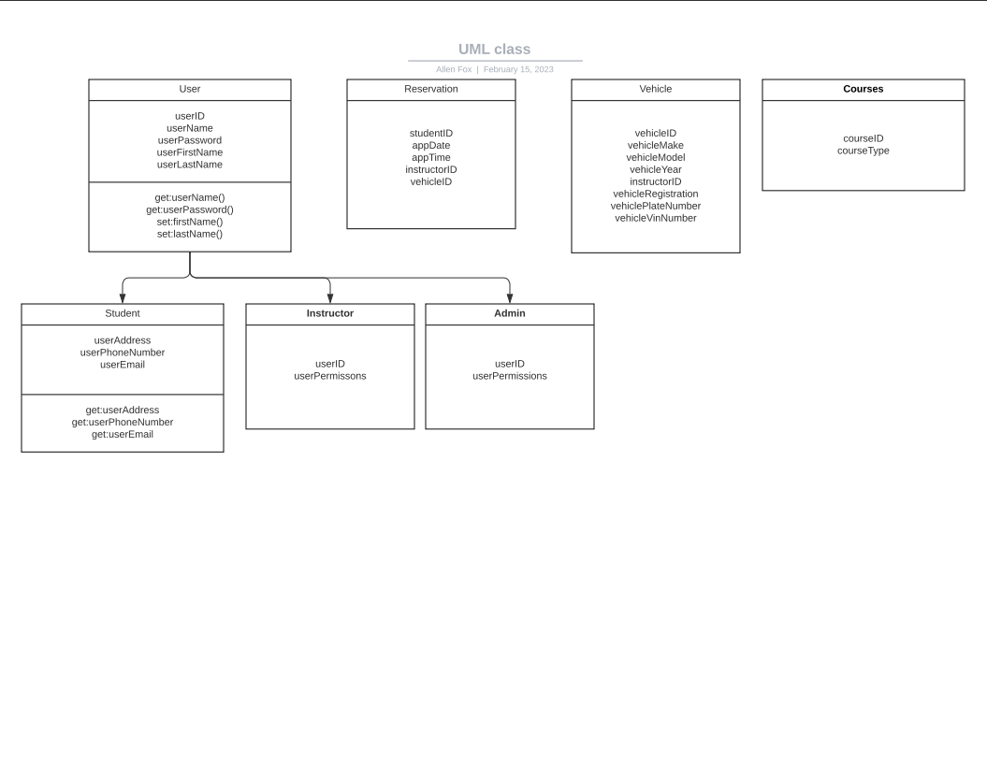

## Technical Requirements

This system will need to be web bases and run off a server that has the ability to host multiple users, stability, availability and expandability. This would be done by leasing a server from a third party vendor that specializes in the upkeep and maintenance of business servers. The platform on which the system is built should allow all users to being able to login and utilize the site on multiple devices such as android, apple and windows based systems. System will need to be monitored and make sure that the user and company data is not at risks of compromise. Firewalls and security software should be in place as well as the ability to have a network professional monitor networking traffic and data. All information stored on the servers should be encrypted to ensure security. A payment system will be incorporated to allow users to pay for classes and materials as needed. The ability to export reports will be available to those who have the correct administrative rights to monitor sales, users progress, edit information and add or change courses. A scheduling system will be put in place to allow users to schedule driving class with instructors of there choosing. The user can also cancel and reschedule those appointments as needed.

Other technical information for the DrivePass system would include: An application running on a Linux system for full customization of the kernel and client’s needs. The database should be SQL unless specified differently by the client. There should be security features in place to support the integrity of both the users and the systems data and structure. User logins will require a 2-way authentication for extra security, the users will have three attempts before being lockout of their account. The site should use HTTPS and backed by a well setup firewall making sure non necessary ports are blocked. There will be a home screen that when correctly logged into will take you to a main menu that will allow the user to navigate to any features available to them as they wish. The profile page will be where the user will enter all personal information.